**Lab 3 Name _______________________________________**

**MCSE 1**

**Objective:**

- Configure Windows 7, Windows 8, and Windows 10 clients on various networks to

practice network principals.

**Procedure:**

___ Make sure Ottawa, Hamilton, and Saskatoon are connected to VMNet2.

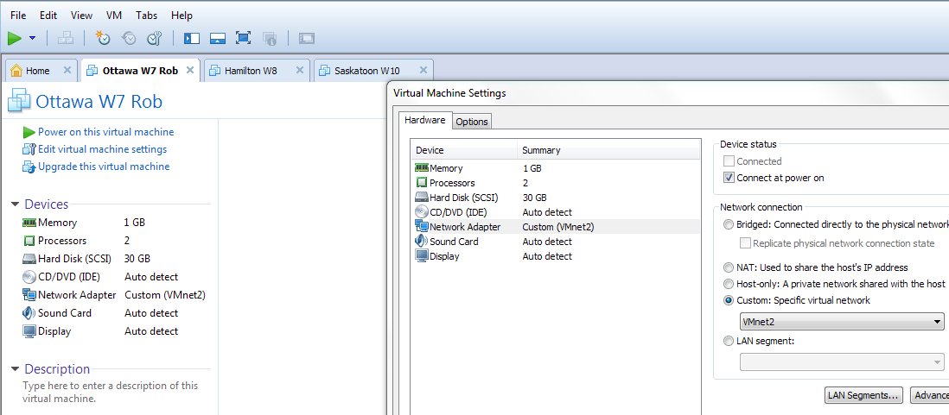

**Single-click**

**Set to VMnet2**

**Single-click**

Fig. 1 Connecting the virtual machine to VMNet2

___ Make sure all 3 virtual machines are set for at least 1 GB. You can change the amount of RAM allocated to virtual machine the same way you set the VMNet connection.

___ Start Ottawa, Hamilton and Saskatoon.

Your network at home has a router that acts like a DHCP server that will automatically give your computers IP addresses. The network in the lab is just three computers connected to a switch. There is no DHCP server to give your computer an IP address.

**Saskatoon:**

___ Configure the network card on Saskatoon to obtain a DHCP address. To do this, right-click on **Network** icon in the task bar and select **Open Network and Sharing Center**. Click on the **Ethernet0** connection. Configure the NIC as shown below.

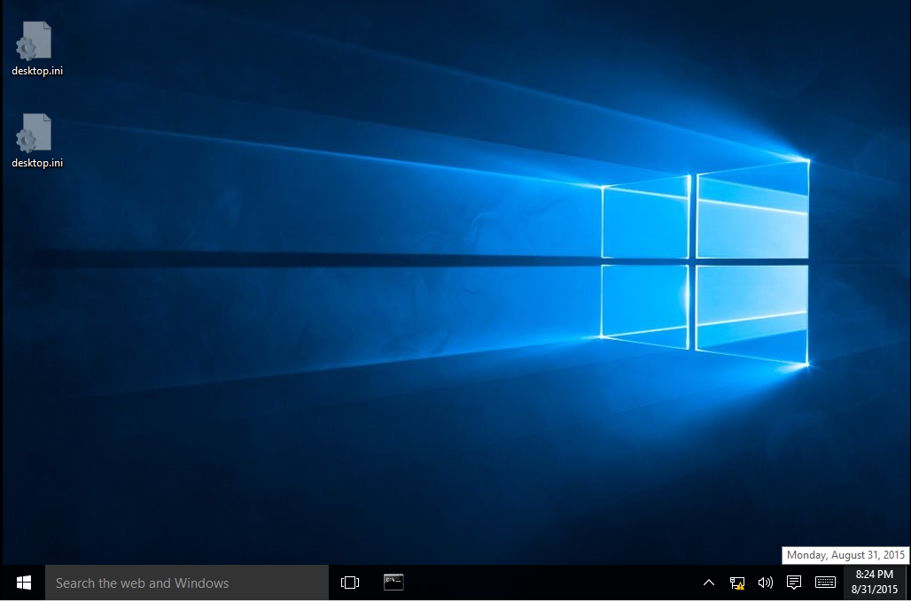

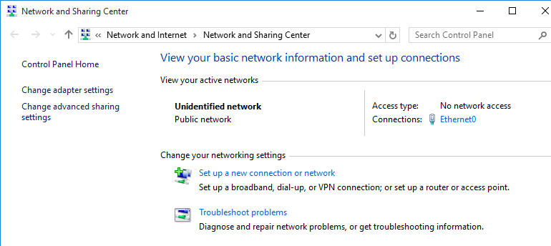

**Double-click on IPv4**

**These fields should be blank**

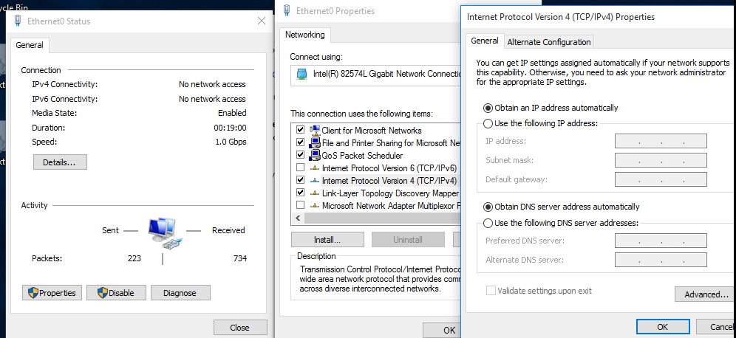

**Clear the box for IPv6**

**Click on Properties**

Fig. 2 Configuring the NIC to obtain an IP address

**Note: There will be no screen captures for this lab. You will answer all the questions on this printed copy of the lab and then submit the paper lab to be marked.**

___ Click on **OK** a couple of times to close the properties page of the network card.

___ In the DOS window type **ipconfig /all**.

**1. Record the following information:**

**MAC address (Physical Address): ____________________________**

**IP Address ____________________________**

**Subnet Mask ____________________________**

**2. How many bits make up the network portion of the IP address? _____**

**3. What class of license is this? ________**

**4. How can you tell what class of license this is?**

**____________________________________________________________**

**5. What is the network address? ____________________________**

The client tried to obtain an IP address from the server. There is no server so the client gave itself an **APIPA** (Automatic Private IP Address) address.

**Ottawa:**

___ Configure Ottawa so it will try to obtain a DHCP address. Follow the instructions

You used for Windows 10.

**6. Record the following information:**

**MAC address (Physical Address): ____________________________**

**IP Address ____________________________**

**Subnet Mask ____________________________**

**7. How many bits make up the network portion of the IP address? _____**

**8. What class of license is this? _________**

**9. What is the network address? ____________________________**

**10. Will Ottawa and Saskatoon be able to communicate with each other? Explain why you think they will or will not.**

___ Ping Ottawa from Saskatoon. You should be successful.

___ Ping Saskatoon from Ottawa. You will probably be unsuccessful.

Windows 10 on Saskatoon may have its firewall on. This blocks the ping command.

___ On Saskatoon, turn the firewall off by following these steps.

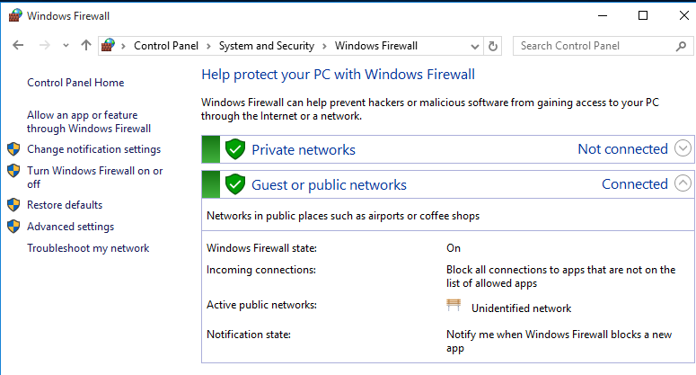

___ Open the **Control Panel**.Select **System and Security**. Scroll to the bottom of the Security Center window. Click on **Windows Firewall**. Select **Turn Windows Firewall on or off**.

Fig. 3 Turning the firewall off

___ Try pinging Saskatoon from Ottawa, again. You should be successful this time.

**Hamilton:**

___ Configure Hamilton so it tries to request an IP address from a DHCP server.

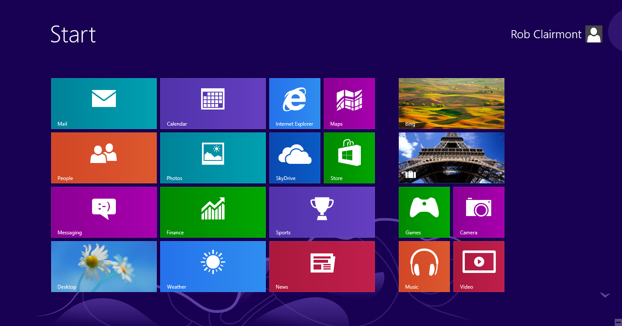

**Right-click on the Network icon**

**Click on the Desktop tile**

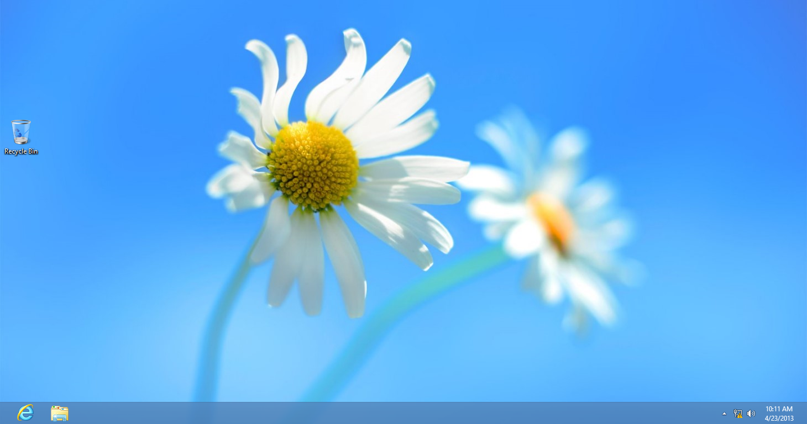

Fig. 4 Configuring the NIC on Windows 8

___ After clicking on the network icon in figure 4, the rest of the steps are the same as they were for Windows 10. See figure 2.

___ Get back to the Start screen shown in figure 4 by pressing the windows key.

___ Click on the dark background of the desktop and type **cmd**.

___ Type **ipconfig /all**.

**11. What is the IP address? ____________________________**

**12. What is the network address? ____________________________**

**13. Is Hamilton on the same network as Saskatoon and Ottawa? ______**

___ Ping Ottawa and Saskatoon. You should be successful.

**Saskatoon:**

___ Configure Saskatoon to use an IP address of 10.1.1.1/16.

___ On Saskatoon, type **ipconfig /all**.

**14. What is the network address? ____________________________**

**15. Is Saskatoon on the same network as Hamilton and Ottawa? ______**

**Hamilton:**

___ Ping Ottawa.

___ Ping Saskatoon.

**16. Record the results of the last 2 pings and explain why you got those results.**

**Ottawa:**

___ Configure the NIC on Ottawa with an IP address of 10.1.2.2/16

**Hamilton:**

___ Configure the NIC on Hamilton with an IP address of 10.1.3.3/16

**17. What is the network address for Ottawa? ________________________**

**18. What is the network address for Hamilton? ________________________**

___ From Hamilton, ping Saskatoon and Ottawa. You should be successful both times.

___ On Hamilton change the subnet mask to 255.255.255.0.

___ From Hamilton, ping Saskatoon and Ottawa. You should be unsuccessful both times.

**19. Why did changing the subnet mask cause Hamilton to not be able to ping Saskatoon and Ottawa?**

___ Configure the 3 virtual machines for so they are using an IP address on a

**private** class B license. Make sure they are all using the same network.

**20. What address did you use for Saskatoon? _____________________**

**21. What address did you use for Hamilton? ________________________**

**22. What address did you use for Ottawa? ________________________**

**23. What subnet mask did you use? ________________________**

**24. What network are the 3 computers on? ________________________**

___ Try pinging from Saskatoon to Ottawa and Hamilton. You should be successful.

___ Configure the 3 virtual machines for so they are using an IP address on a

**private** class C license. Make sure they are all using the same network.

**25. What address did you use for Saskatoon? _____________________**

**26. What address did you use for Hamilton? ________________________**

**27. What address did you use for Ottawa? ________________________**

**28. What subnet mask did you use? ________________________**

**29. What network are the 3 computers on? ________________________**

___ Try pinging from Saskatoon to Ottawa and Hamilton. You should be successful.

___ Configure Saskatoon for 10.1.1.1/24.

___ Configure Ottawa for 10.1.1.2/24.

___ Configure Hamilton for 10.1.1.3/24

___ Ping to make sure you can communicate between the 3 hosts.

**Windows 7 and Windows 8 Tips: Pinning applications to the Taskbar**

With Windows 7, 8 and 10, you can add or pin frequently used applications to the taskbar to make them readily available.

**Ottawa:**

___ Open a command prompt.

___ Notice the icon representing the window appears in the task bar. To make it stay on the taskbar after the window is closed, right-click the icon and select **pin this program to taskbar**.

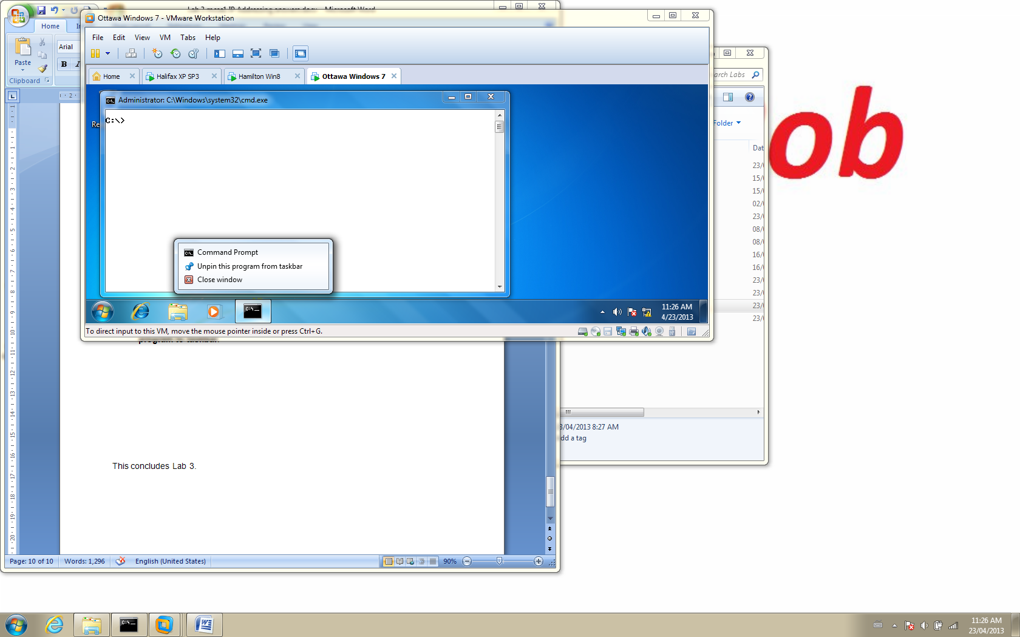

Fig. 5 Pinning the command prompt to the task bar

The same thing can be done with Windows 8.

___ From the start window on Hamilton, click on the dark background on the desktop and type **cmd**.

___ Right-click on the Command prompt box in the upper left corner and select **pin to taskbar** at the bottom of the screen.

___ Return to the **Start** window and click on the **Desktop** tile.

You should see the command prompt icon on the taskbar.

[](http://www.google.ca/url?sa=i&rct=j&q=&esrc=s&frm=1&source=images&cd=&cad=rja&docid=S3hBwotkfOr8NM&tbnid=0lllVOroySOVxM:&ved=0CAUQjRw&url=http://www.businessinsider.com/best-colleges-2010-11?op=1&ei=iLh2UdzfOIn_qwGW9YDYBQ&bvm=bv.45512109,d.aWM&psig=AFQjCNH2sAqziok3yFgvvplvb2Fv4W_JgA&ust=1366821203273324)

***Ok….***

***You’re***

***done !!!!!!!***